Trevlin Six

Telecoms Project Documentation

PRO330

Prof. Burk

Contents

Executive Summary 3

Project Details 3

Network Diagram 3

PBX Setup Documentation 3

Softphone Setup 4

Switch Config 4

Cisco Phone Config 9

TFTP Server Config 9

IP Phone Provision Files 9

Provisioning the Cisco IP Phones 9

References 10

Executive Summary  
 For this project, we were tasked with choosing and configuring an on-site PBX that had soft and hardphone capabilities, voicemail, music on hold, and call parking. We got hands-on experience with Cisco IP phones and the PBX of our choosing as well as the Raspberry Pi.

# Project Details

During our journey to getting everything to work in tandem with each other, many hardships and successes were achieved. In the first two weeks, my group and I restarted from the ground up three times before landing on the configuration that would see us through to success. Our milestones were getting the softphones configured and working, setting IP addresses on both the WAN and LAN networks on the Raspberry Pi, configuring the TFTP server correctly, and getting our hardphones provisioned and working. We chose 3CX because it is a simple and cost-effective PBX system that allowed for on-premises hardphone and softphone capabilities. We chose Solarwinds as our TFTP server to provision the hardphones because it is simple to implement and free. We did not implement any successful scheduling scheme because of our consistent backtracking and reworking.

Network Diagram

PBX Setup Documentation

1. Open a terminal: To get started, open a terminal on your Raspberry Pi. You can do this by pressing Ctrl+Alt+T on your keyboard or by opening the terminal emulator application from your desktop environment.
2. Download the 3CX installation package: Use the following command to download the 3CX installation package:

wget https:/downloads-gloabal.3cx.com/downloads/misc/d10pi.zip; sudo bash d10pi.zip

1. Follow the on-screen instructions: During the installation process, you will be prompted to enter your license key, configure your network settings, and set up your SIP trunks and extensions. Follow the on-screen instructions carefully to ensure that 3CX is set up correctly.
2. Start 3CX: Once the installation is complete, use the following command to start the 3CX service:

sudo systemctl start 3cxpbx

This will start the 3CX service and allow you to begin using it.

Softphone Setup

1. Navigate to the 3CX webpage by going to the localhost IP address.
2. Setup users by clicking on the user tab and following the on-screen instructions.
3. Using the target softphone, download the 3CX application.
4. Scan the User QR code using the softphone to provision the phone.
5. Rinse and repeat with another softphone and user.

You should now have two users and two provisioned softphones.

1. Using one phone, test your progress by calling the other.

Switch Config  
 1. Ensure all needed ports are on the same vlan.

2. Enable Power over Ethernet (PoE) on all ports.

** The show run below is what my switch looked like when we finished.

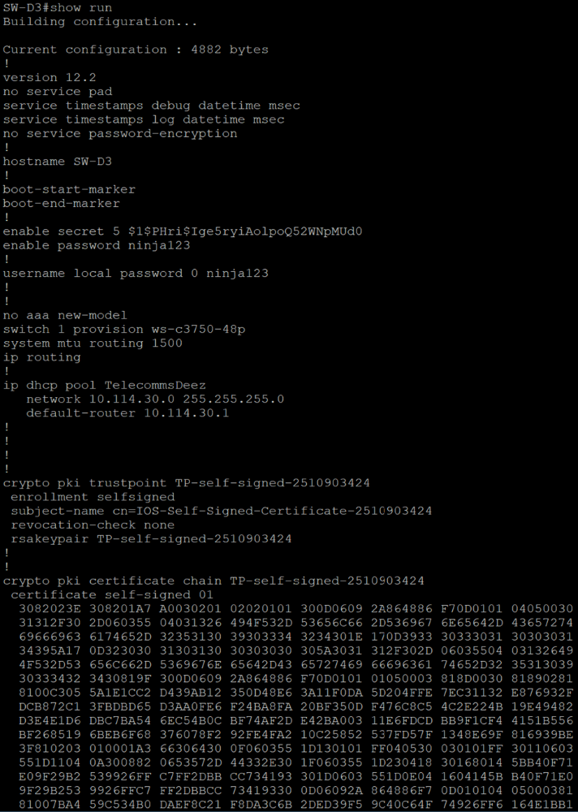

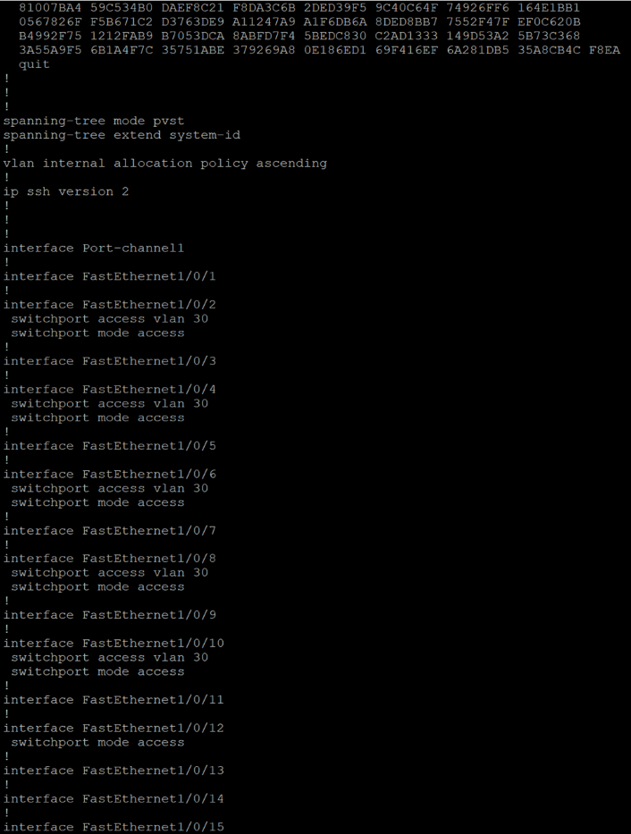

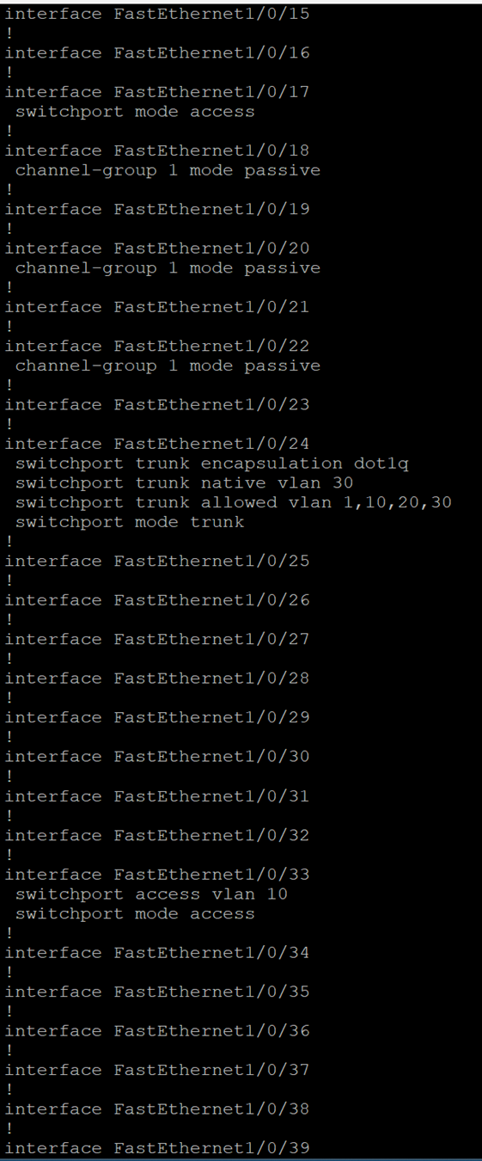

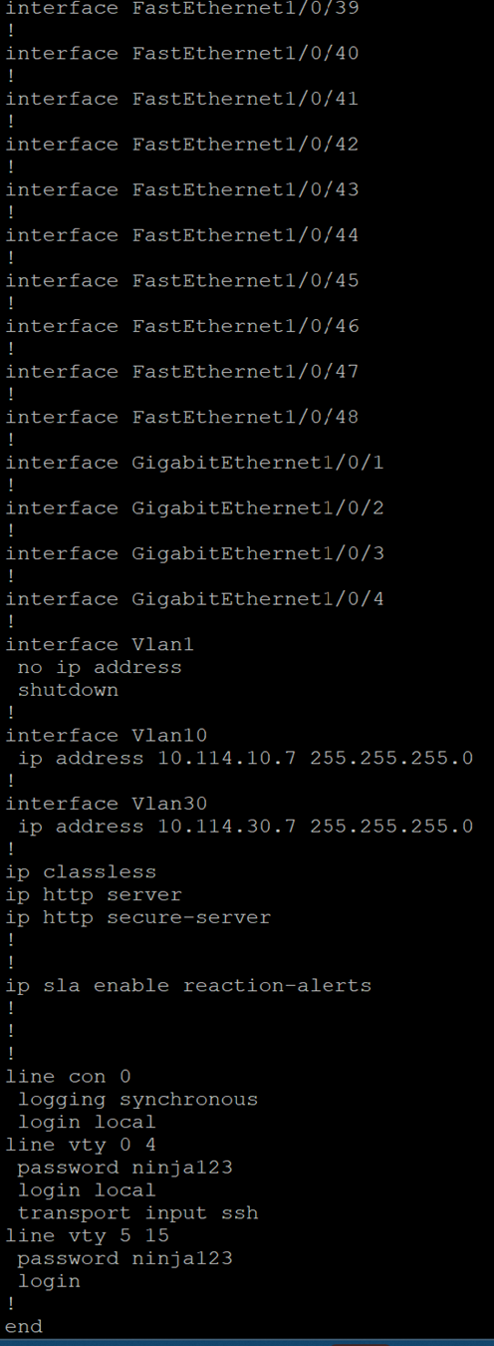

Cisco Phone Config  
 1. Plug phones into switch.

2. When they turn on, hold ‘#’ until the phone says ‘Reset Mode’.

3. Enter 123456789*0# in succession.

4. Press no when the phones ask whether you would like to save config files.

TFTP Server Config  
 1. Download and install Solarwinds TFTP Server software on an internet enabled device.

2. Open Solarwinds, tell Solarwinds where to find the provisioning files from 3CX.

3. Plug host device into the switch and give it a static IP address.

IP Phone Provision Files  
 1. Navigate to 3CX management page using localhost:5000.

2. Click on a user in the ‘user’ tab to provision a hard phone to that user.

3. Click on the ‘Phone Provisioning’ tab.

4. Click on the ‘add’ button to add a phone.

5. Navigate the drop-down menu to find your model of IP phone.

6. Enter the MAC address of the IP Phone in the text box provided.

7. Scroll down until you see the Provisioning Files hyperlink.

8. Download the provisioning file.

9. Put that file in the path that the Solarwinds server is looking at.

Provisioning the Cisco IP Phones

When the IP Phones are first plugged in, they will request the phone’s provisioning file from the TFTP server.

1. Ensure that the TFTP server is plugged in and connected to the switch that the phones are.
2. Go to the Cisco IP Phone Settings and hit 9.
3. Enter the password. Should be ‘cisco’.
4. Go back to the settings menu, hit 3.
5. Hit 32. Change this option to yes.
6. Hit 7. Select edit and specify the IP address of the TFTP Server.

You should now have two provisioned hardphones.

1. Call from one phone to another to test.

**IF your users have a provisioned hardphone, their provisioned softphone will not work. To get around this, either have a third user with a softphone and no hardphone or assign the hardphones to new users without softphones.

# References

3CX Documentation - <https://www.3cx.com/docs/>

Cisco IP Phone Documentation - <https://www.google.com/url?sa=t&rct=j&q=&esrc=s&source=web&cd=&cad=rja&uact=8&ved=2ahUKEwj30NfX-p39AhVykGoFHa7SCTwQFnoECCEQAQ&url=https%3A%2F%2Fwww.cisco.com%2Fc%2Fen%2Fus%2Ftd%2Fdocs%2Fvoice_ip_comm%2Fcuipph%2F7960g_7940g%2Fsip%2F2_0%2Fenglish%2Fadministration%2Fguide%2Fver2_00.pdf&usg=AOvVaw0jx8ZjNQySzA2KI9Ja5EGP>

Cisco Switch Documentation - <https://www.google.com/url?sa=t&rct=j&q=&esrc=s&source=web&cd=&cad=rja&uact=8&ved=2ahUKEwjlxdKM_J39AhX-k2oFHUSlBZ4QFnoECAsQAQ&url=https%3A%2F%2Fwww.cisco.com%2Fc%2Fdam%2Fen%2Fus%2Ftd%2Fdocs%2Fswitches%2Flan%2Fcatalyst2960%2Fhardware%2Fquick%2Fguide%2F9368.pdf&usg=AOvVaw1lho9-1yQfpC84WEByns8B>